Project Design Phase-II
Data Flow Diagram & User Stories

Date | 27 October 2026
Team ID | Not provided by user
Project Name | Global Olympic Sports Performance Analysis
Maximum Marks | 4 Marks

Data Flow Diagrams:
A Data Flow Diagram (DFD) is a traditional visual representation of the information flows within a system. A neat and clear DFD can depict the right amount of the system requirement graphically. It shows how data enters and leaves the system, what changes the information, and where data is stored.
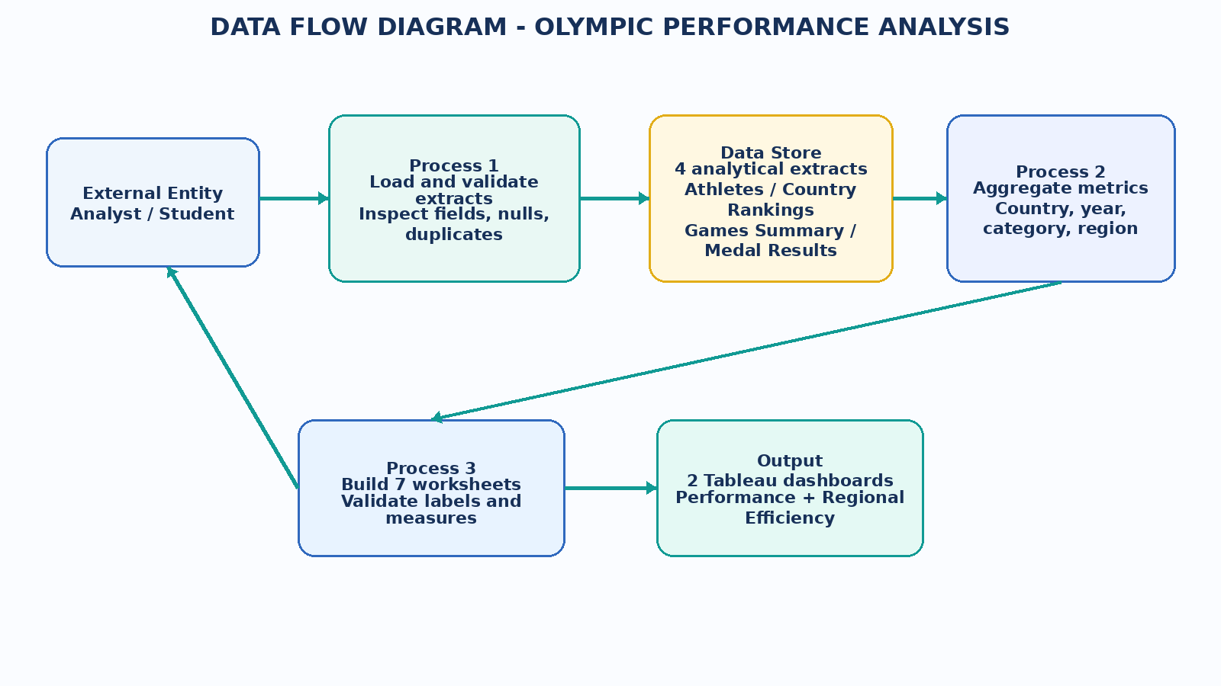
Figure 1. Data flow from packaged extracts through validation and Tableau analysis to dashboards.
DFD Symbol Legend
Symbol | Name | Description
Oval / Rounded  shape | External Entity | A person, organization, or system outside the project that sends or receives data (e.g., Customer, Payment Gateway).
Rectangle with  numbered header | Process | An activity that transforms incoming data into outgoing data (e.g., Validate Request, Process Order).
Rectangle (solid fill, no number) | Data Store | A place where data is held for later use (e.g., Customer Database, Inventory).
Labeled arrow | Data Flow | The movement of data between entities, processes, and data stores, labeled with what data is being passed.

Example: DFD Level 0 (Industry Standard)



User Stories
Use the below template to list all the user stories for the product.
User Type | Functional Requirement (Epic) | User Story Number | User Story / Task | Acceptance criteria | Priority | Release
Student / Analyst | Country comparison | USN-1 | As an analyst, I can compare countries by total medals and overall rank. | Country and total-medal measures are visible with clear sort/rank context. | High | Sprint 1
Student / Analyst | Trend analysis | USN-2 | As an analyst, I can inspect total medals awarded by Olympic year. | A year-based line chart is labeled and values are aggregated consistently. | High | Sprint 1
Student / Analyst | Category analysis | USN-3 | As an analyst, I can compare average medals by sport category. | Category labels and average measure are shown in the relevant view. | High | Sprint 1
Student / Analyst | Regional analysis | USN-4 | As a researcher, I can compare medal efficiency by region. | Regional aggregation and efficiency definition are visible or documented. | High | Sprint 2
Student / Analyst | Interactive filters | USN-5 | As a viewer, I can narrow the country rank range or select host-advantage groups where available. | Filters update the related views and the selected state is clear. | Medium | Sprint 2
Student / Analyst | Investment analysis | USN-6 | As a researcher, I can explore investment score alongside medal output. | Scatter plot identifies countries and does not imply causation. | Medium | Sprint 2
Student / Analyst | Regional distribution | USN-7 | As a viewer, I can see the medal distribution across regions. | Region categories and totals are represented in a clearly labeled chart. | Medium | Sprint 2
Reviewer / Instructor | Dashboard review | USN-8 | As a reviewer, I can inspect both dashboards and compare views. | Two dashboard tabs are present and each view has a descriptive title. | High | Sprint 3
Reviewer / Instructor | Evidence package | USN-9 | As a reviewer, I can open the workbook and review the report/evidence files. | TWBX and supporting files are packaged with setup and limitation notes. | Medium | Sprint 3
Data steward | Data-quality review | USN-10 | As a data steward, I can review source tables and identify missing or duplicate values. | A data-quality checklist and any outstanding checks are documented. | Medium | Sprint 3
Student / Analyst | Interpretation | USN-11 | As a viewer, I can read definitions and avoid unsupported cause-and-effect claims. | Report includes metric caveats and avoids claims not supported by the extracts. | High | Sprint 3
Project owner | Publishing | USN-12 | As the project owner, I can prepare the workbook for Tableau Public sharing. | Workbook opens locally and source/publication permissions are checked before sharing. | Low | Sprint 4

Implementation note: The supplied Tableau workbook proves the dashboard layer and contains four packaged Hyper extracts. Any upstream raw-data ingestion, Snowflake loading, and row-level quality checks must be verified separately because no executed database log was included.

